Task 20 Outputs

Question 1: Date Picker

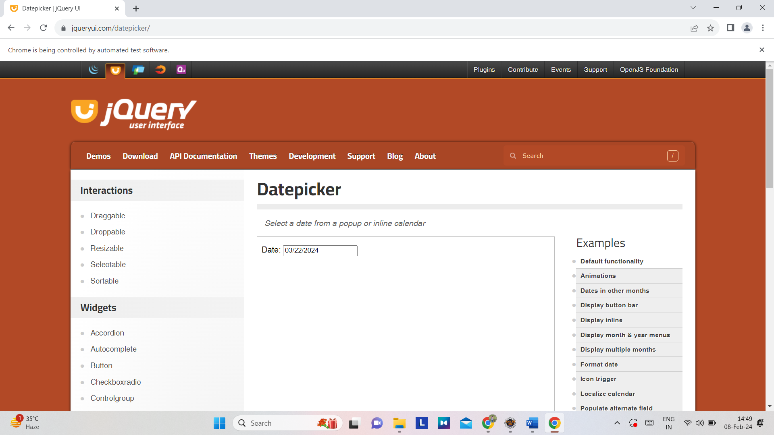

Screenshot showing date selected

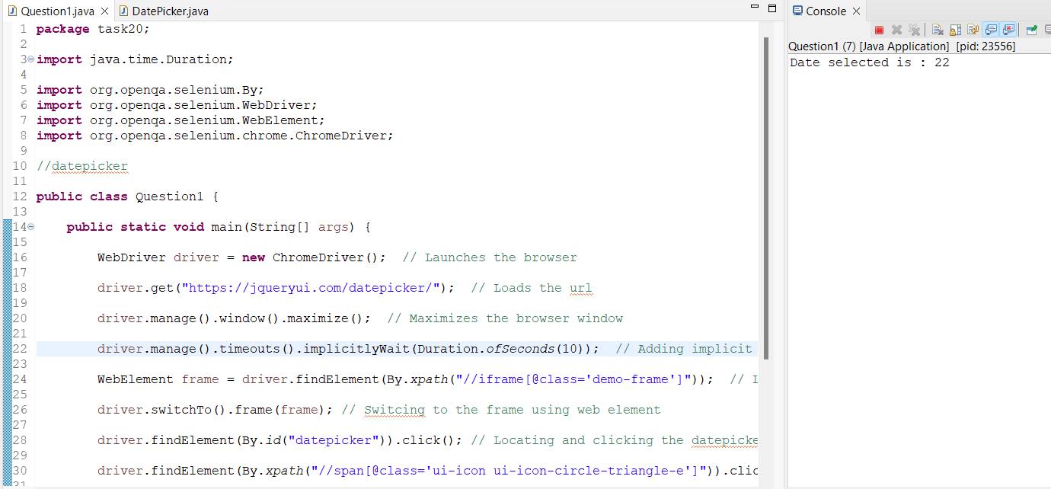

Console output

Question 2: Guvi account creating and login

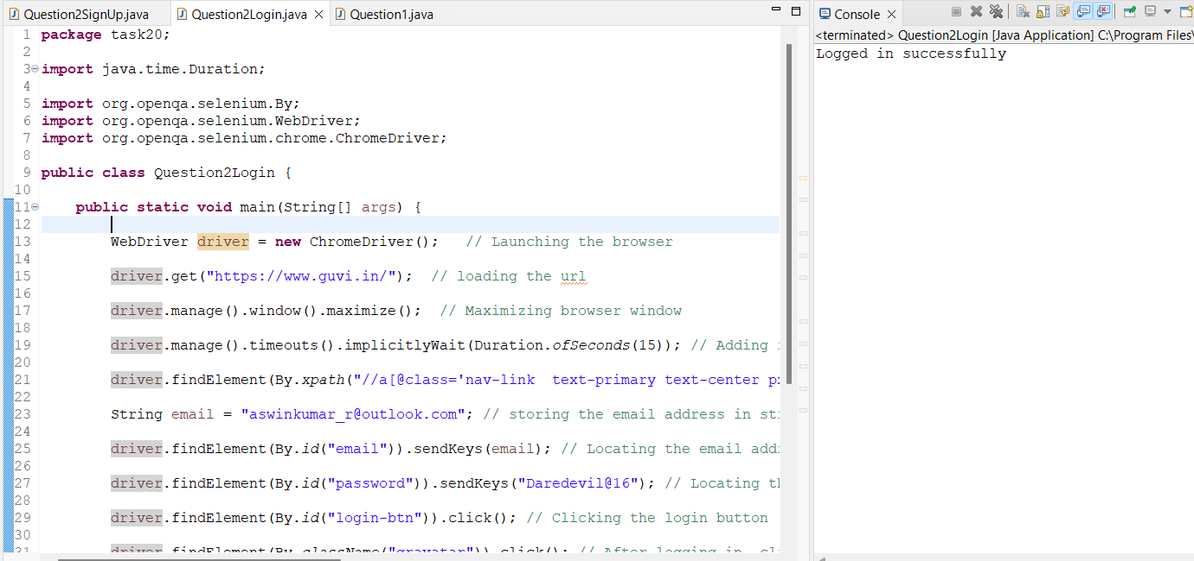

Console output

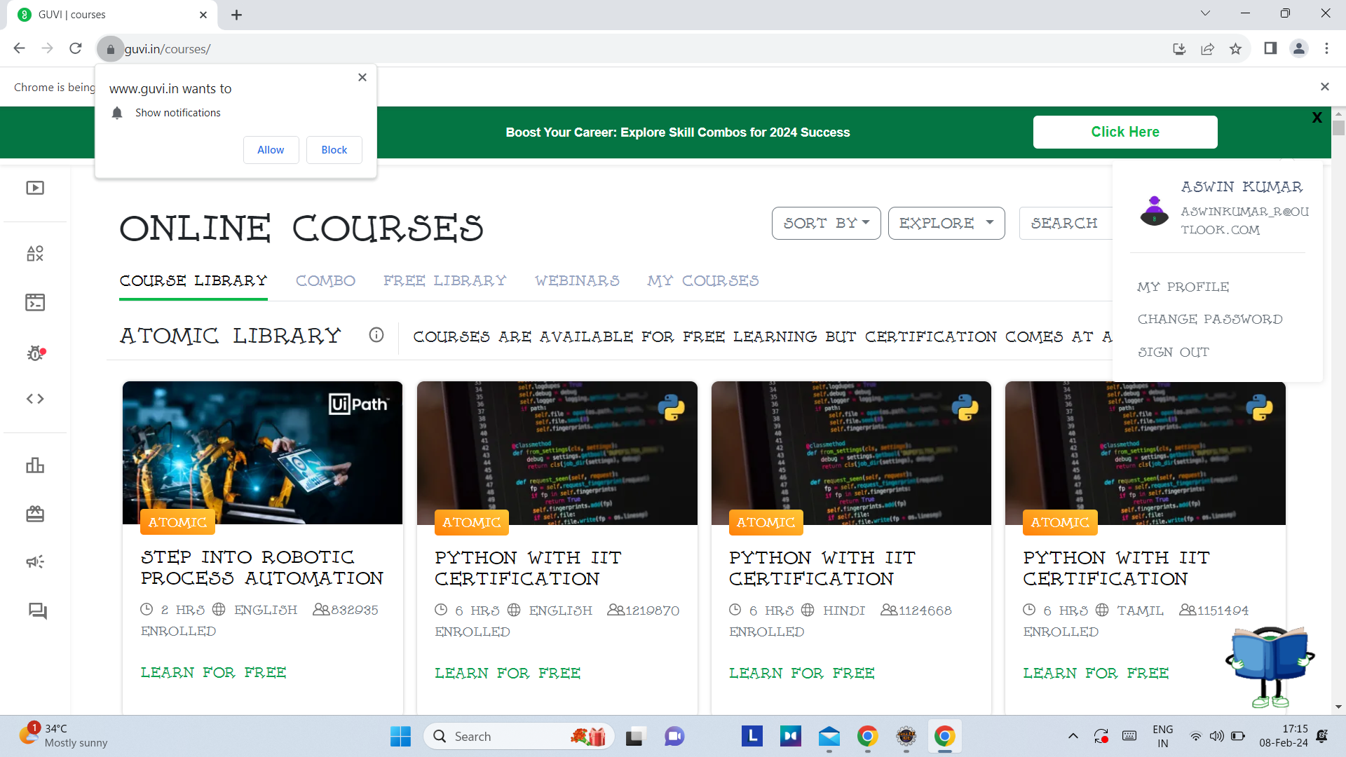

Screenshot shows user logged in successfully